**ref. 52942**

**WHEEL ROTATION MOTOR AND GEARS TOOL BENZ/MAN 3 GEAR**

**Function**

It allows the vehicle's wheels to rotate.

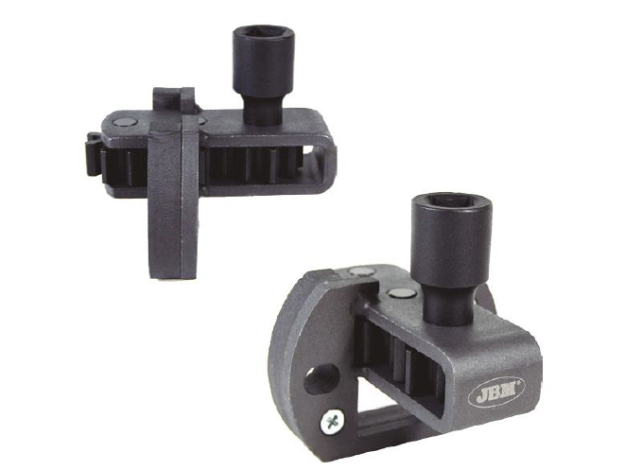

|  |  |
| --- | --- |
|  |  |

**Features:**

For Mercedes Actros and Atego

For MAN engines with 5, 6, and 8 cylinders